AN ANALYSIS DOCUMENT OF COVID-19 CASES
Project title: Covid-19 analysis and visualization tools
Introduction:
Covid-19 has being a serious pandemic years back, which has cause a lot of life’s and separation of families. This document contain a brief demonstration of how data analysis was being carried to visualize the number of deaths, recovery and critical cases in each country.
Scope:
- The data set of covid-19 cases was gotten from Kaggle website
- The software used to carry out visualization and data cleaning is jupyter-notebook
- Python libraries like; pyplot,matplotlib and seaborn was used to carried out visualization.
Illustration:
- Data Processing
- Carried out collection of data and also identified missing values and duplicate values from the dataset. Identifying missing values of a dataset is very important and help it help us identify anomalies of data

Fig1.screenshot of data collection
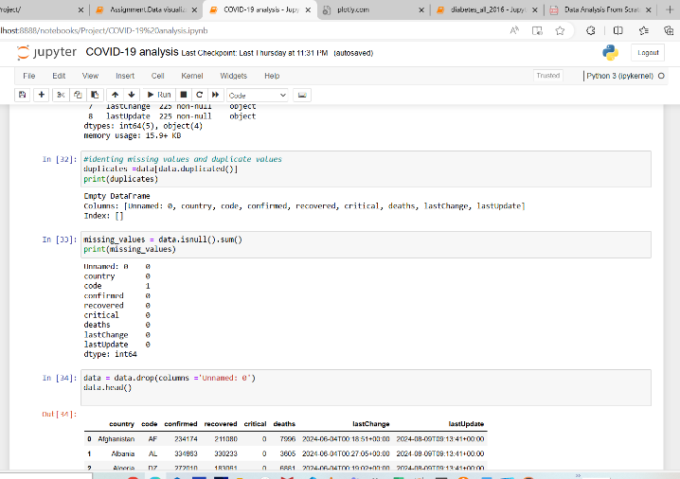

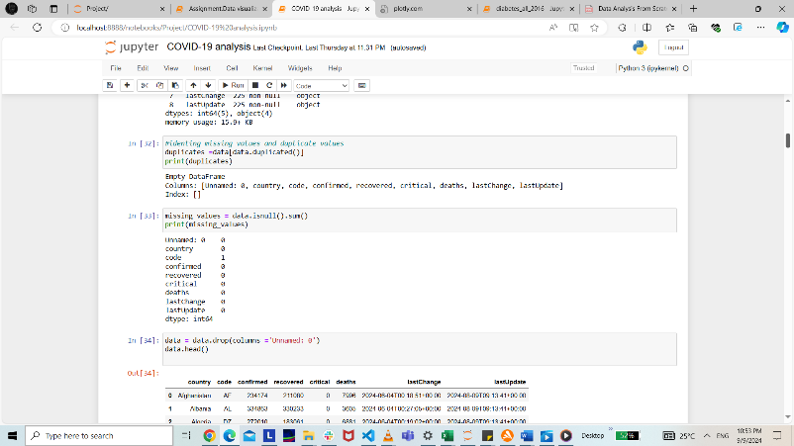
Fig 2:view of missing values and duplicate values

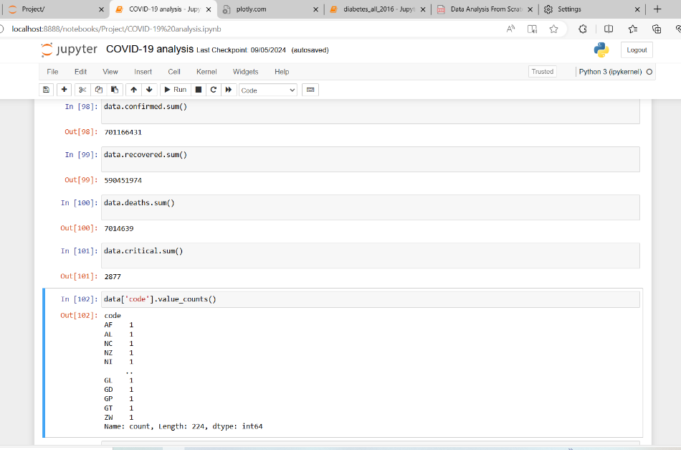
Fig3:calculating the sum of each cases of covid-19

The image above shows the calculated sum of each cases that occurred in different countries around the world like; confirmed, recovered, critical and deaths cases.

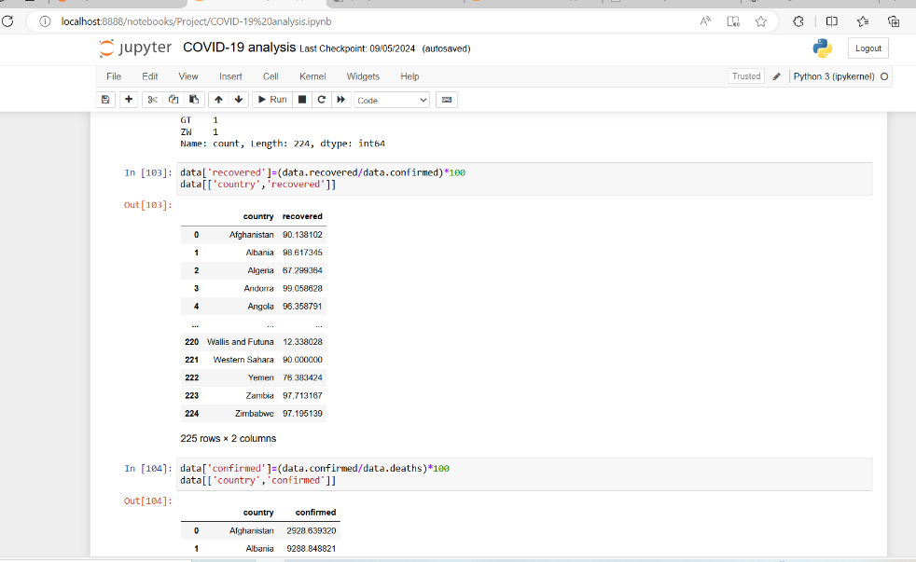
Fig4: View of the recovered cases
The above image shows the calculated percentage of recovered cases of different countries.
- Carrying out EDA(Elaboratory data analysis)

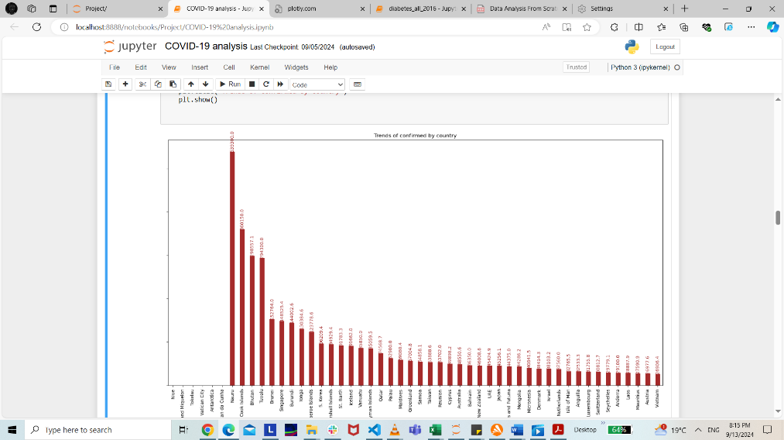
Fig4:A bar chart of confirmed cases
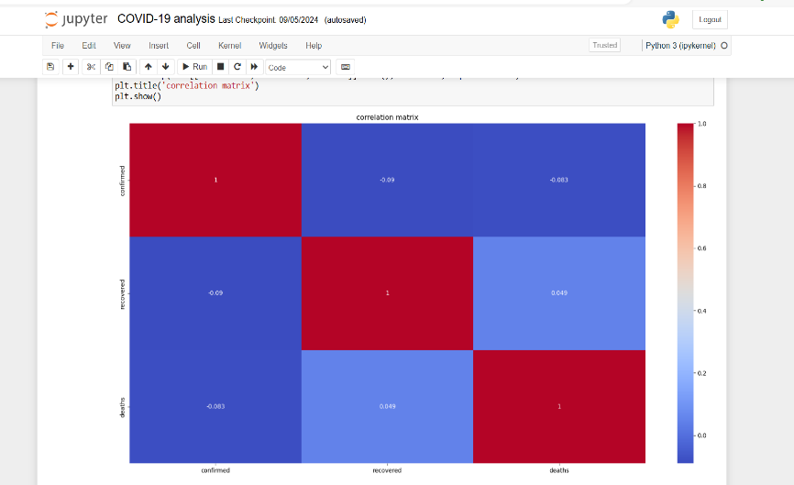
fig5:A correlation matrix indicating cases of covid-19 victims
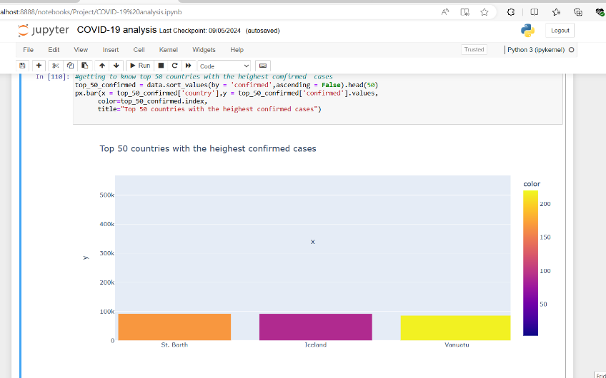
Fig6: A bar chart of top-50 highest confirmed cases

